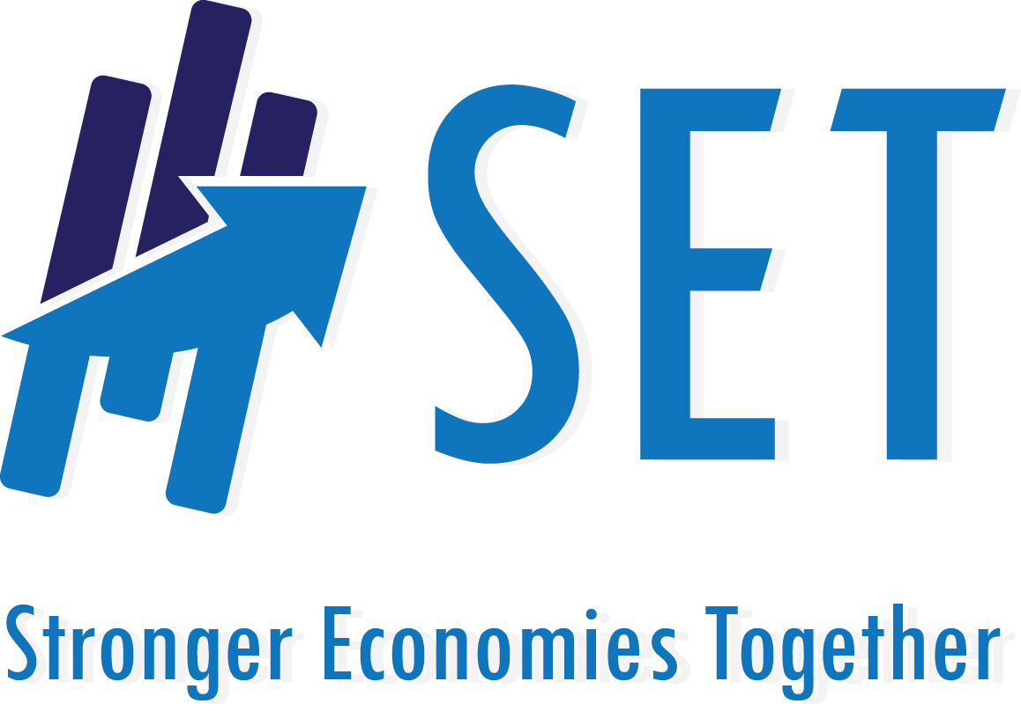

Regional Application
2015

About Stronger Economies Together (SET):

In many counties – especially counties with smaller populations -- finding ways to create, attract, and retain jobs is a challenging process. Pursuing economic development as a single rural county in isolation from other nearby counties is becoming increasingly ineffective. In today’s global market place, economic development progress is more likely to be realized when rural and metro counties work together as a multi-county region to assess, design, and implement plans that build on their assets and comparative economic strengths.

Purpose:

The purpose of SET is to strengthen the capacity of communities/counties in rural America to work together in developing and implementing an economic development blueprint for their multi-county region, one that strategically builds on the current and emerging economic strengths of that region. In short, SET is a High Quality regional economic development Plan (HQP) development process.

Sponsors:

The Stronger Economies Together (SET) Program is sponsored by USDA Rural Development (USDA RD), in partnership with the Southern Rural Development Center, its three sister Regional Rural Development Centers, and their land-grant university colleagues. One of the land-grant institutions playing a key coordinating role is the Purdue University Center for Regional Development (PCRD).

Eligible States/Regions:

Regions located in the following states are invited to take part in Phase V of the SET program. These states are Illinois, Indiana, Iowa, Louisiana, Michigan, Missouri, Nebraska, New Mexico, North Carolina, North Dakota, Oklahoma, South Dakota, and Virginia.

PLEASE NOTE that counties that make up your region must be contiguous to one another.

What Types of Regions Are the Most Likely to Benefit from SET?

Regions have entered the SET program from a variety of starting points. Some regional groups are newly formed, while others have been in place for an extended period of time. While SET is particularly appropriate for newly forming regions, it can also be helpful for more established regions that are interested in exploring new opportunities or revisiting/refining existing plans (e.g., such as the region’s Comprehensive Economic Development Strategy (CEDS).

Successful SET regions share five important features and as such, regional team members are urged to fully embrace the following attributes:
- Recognition that regional strategies represent a key part of the overall economic development blueprint for the region’s small communities, cities, and counties;
- Openness to exploring economic activities that focus on strengthening a core number of existing or emerging economic clusters that can expand the economic vitality of the region ;
- Commitment to gathering inputs and insights from a large diverse set of institutions and people when determining the region’s goals and plans, going well beyond a reliance on economic development professionals and elected officials;
- Willingness to take a fresh look at where the region is, where it wants to go, and the best way to get there;
- Commitment to devote significant time and energy needed (a) to actively participate and work through all SET planning materials as a regional team; and (b) to use this process to develop a High Quality regional economic development Plan (HQP) that is developed and implemented by the regional team.

Planning Process: A Key Component of the SET Program:

The SET program includes four (4) core modules plus a set of modules tailored to each region’s particular needs. The discussion and application of the modules are facilitated with each regional team on a face-to-face basis. State Resource Teams, made up of representatives of your state’s land-grant university-based Extension Service, state USDA Rural Development staff, and other key partners, will coach the SET planning process and serve as resource persons to your team. Approximately 20+ hours of active facilitated planning will be provided to each regional team over the course of several months. Selected regional teams are expected to actively participate in the entire process. More information about the stages of the process is available at: http://srdc.msstate.edu/set/files/set_overview.pdf.

The High Quality Plan: A Critical Component of the SET Program:

The SET planning process is a means to an end. The end, of course, is a region with a stronger economy. Regions that join SET are required to develop and implement a High Quality Plan (HQP). The attributes of a HQP is available here - http://srdc.msstate.edu/set/high_quality_ed_plan.html. Creation of a HQP positions the region for implementation of the plan and a stronger economy.

Technical Assistance to Begin Implementing the Plan Available to Regional Teams:

Aside from facilitating the SET process, the State Coaching Team will provide in the range of 20 to 40 hours of technical assistance to your regional team for a period of 6-12 months once your team has completed its SET planning process. By technical assistance we mean that Extension educators and USDA RD State staff will assist your team in securing the type of information (e.g., data, expertise, advice), or to provide facilitation or additional coaching on a topic if needed to guide your regional team as you begin to implement your High Quality Plan (HQP). This includes securing the help of university colleagues or USDA RD state staff members who may have the background/expertise needed by your team.

Major Benefits to Successful Applicants:

Each selected region will receive a number of important benefits including:
- Valuable coaching on the core building blocks that will serve as the foundation for developing and launching your region’s HQP.
- In-depth data that are tailored to your region, information that helps delineate the critical drivers of your economy (including the presence or emergence of regional clusters).
- Tools that uncover local assets and resources that can be tapped to advance your region’s economic strategies and actions.
- Coaching and technical assistance from Extension educators, USDA RD State staff, and the Regional Rural Development Centers to guide your regional team as it begins to implement its HQP.
- Opportunity to share information and gather ideas/insights from other regions across the nation involved in the SET program.

The Rural Requirement:

Each region must encompass three or more counties and the population and/or geographic area of the region must be at least 51% rural in nature OR (2) 75% of the region’s land area must be located in rural areas of that region. (See definitions and resources in the “Additional Information” section of this document.) While a region may cross state boundaries (something we encourage if it makes sense for your region), the counties that make up that multi-state region must meet the rural requirement as well.

Deadline Date for Applications:

Applications are due electronically no later than May 7, 2015 by 11:59 p.m. local time. Please submit your application to: Becky Bowen. You will receive an acknowledgement of your application within two business days. We urge all applicants to contact us immediately if they have not received an acknowledgement within this time period.

All applications will be carefully studied by a State Resource Team representing the state’s USDA RD office, Cooperative Extension Service, and other key community/economic development organizations or agencies in your state. The State Resource Team may contact applicants in order to conduct site visits and a tour with representatives of your group. Once the State Resource Team has completed its evaluation of all SET applicants, it will submit its recommendations to the national USDA RD office. Key representatives from USDA RD and the Regional Rural Development Centers will review the national pool of finalists. The national USDA RD Office will make the final decision regarding regions in each of the target states that will be invited to be part of the SET program. This announcement is expected to take place in summer by June 30.

Questions?

If you have any questions, please contact:

Becky Bowen, Program Manager at blbowen@ncsu.edu or (919) 628-4317
Brian Queen, Community Programs Specialist at brian.queen@nc.usda.gov or (919) 873-2072

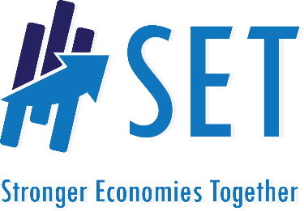
APPLICATION FORM
Stronger Economies Together Program
Deadline for Applications: May 7, 2015; 11:59 p.m. Local Time
Please Complete All Sections of the Application Form

Part A: Information about Your Regional Team

- Name of your Regional Team (if none has been decided yet, just provide a name that best describes the geographic area of your regional group).
________________________________________________________________________________

NOTE: For purposes of this application, a region is defined as an area that encompasses three or more counties that are contiguous to one another. It is acceptable for your region to cross state boundaries.

- What counties are included in your region?______________________________________________
_________________________________________________________________________________

- Main contact person for your regional team:_____________________________________________

Please indicate whether:
- Email address:_____________________________________________ Business OR Personal

- Telephone number: _________________________________________ Business OR Personal

- Mailing address: Business OR Personal _________________________________________________________

- Please place an “X” by the ONE statement that best describes your regional team.

Our regional team:
Is brand new and has been organized for the purpose of applying for the SET program

Has been organized for more than one year, but is inactive and/or in need of help to get back on track

Is less than one year old and is still trying to get off the ground in developing a sound regional economic development plan

Has been in place for one year or more and has developed OR is pursuing an effective regional economic development plan. The group is open to reconsidering all aspects of the plan

Part B: Brief Economic Description of Your Region (250 word limit)

Present an overview of why the proposed area is an economic region and the sectors that represent key drivers of your economy. Here are the types of information you might include in your description:

- Economic region: Is this region an economic region? For instance, what evidence do you have that the counties in your region, taken together, constitute an economic region (or an emerging economic region)?

- Key sectors that make up your economy and the current health of these sectors: In general, tell us about how the economy of your region is doing and why. Are your key sectors stable, expanding, declining, or mixed in terms of their performance?

Part C: History of Working Together in the Region (250 word limit)

Please describe your regional team’s history of working together on economic development issues in the past. What have been your successes, if any? What have been your challenges or barriers, if any? Please describe any previous planning efforts among the regional team members. Please note that points are not awarded for the volume of your past history, since SET is ideal for new groups. Rather, points are awarded for the completeness and clarity of the description.

Part D: Challenges of Pursuing a Regional Economic Development Plan (250 word limit)

In Part C, you discussed the history of working together across your region. In this part, please focus on the future and, specifically, what you anticipate will be some of the key challenges that your team will face as it seeks to develop and launch a regional economic development plan? Please address how you may resolve these issues. For instance, consider potential challenges related to:
- Recruiting a large and diverse set of regional team members that will work together through the entire planning process
- Developing a regional mindset
- Implementing the plan
- Other key challenges your region believes it may encounter

Part E: Interest in the SET Initiative (400 word limit)

- Explain why your regional team would like to be part of the SET program. What are the primary factors influencing your interest in SET right now?

- What do you hope/expect will happen in your region due to your participation in SET?

Part F: Current Members of Your Regional Team and Commitment Letters
Please provide the names of the individuals and their respective organization/agency affiliations that have agreed to be part of your regional team. More effective regional teams include representation from many sectors. Applications with broad representation will score higher. ALSO, a signed commitment letter from each person on your team that states that he/she has agreed (1) to actively participate in the SET planning process and (2) to honor the commitments stated below must be included with this application.

Name of Regional Team Member | Primary Organization/Agency the Person Represents | Have Commitment Letter from this Person?
  - Yes
  - No
  - Yes
  - No
  - Yes
  - No
  - Yes
  - No
  - Yes
  - No
  - Yes
  - No
  - Yes
  - No
  - Yes
  - No
  - Yes
  - No
  - Yes
  - No
(Feel free to attach a separate sheet if needed to add more Regional Team members)

Commitments: Success of SET depends on the commitment of all regional team members to the following:
- Recognition that regional strategies represent a key part of the overall economic development blueprint for the region’s small communities, cities, and counties;
- Openness to exploring economic activities that will focus on strengthening a handful of key existing or emerging economic clusters in the region;
- Commitment to gathering inputs and insights from a large diverse set of institutions and people when determining the region’s goals and plans;
- Willingness to take a fresh look at where the region is, where it wants to go, and the best way to get there;
- Commitment to devoting the significant time and energy needed a) to actively participate and work through the entire SET planning process as a regional team; and b) to use this process as the foundation for a High Quality regional economic development Plan that is developed and implemented by the regional team.

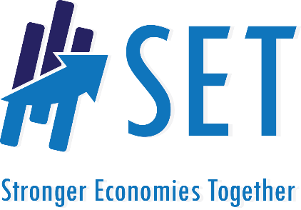
Additional Information for Applicants

Definition of Rural

For purposes of this application, rural refers to counties that are classified as nonmetropolitan areas by the Office of Management and Budget. Nonmetropolitan areas can be either micropolitan or noncore counties. This information can be downloaded from the following SRDC web site: http://srdc.msstate.edu/set/definitionrural.html

How Proposals Will Be Scored

All proposals will be scored on a 200 points basis. The following details the maximum amount of points associated with each component of the SET application. Please note that in addition to the scores associated with each SET application, USDA RD will be looking for other key elements in the selection process, such as regions with: (a) a different mix of recent regional work history; (b) varying levels of ruralness; (c) different economic characteristics; (d) crossing state lines; (e) varying levels of social and demographic features (i.e., high poverty, population migration patterns, and racial/ethnic changes). These additional elements are intended to ensure that a good mix of regions is part of the SET program.

Maximum Points Possible
Description provided of your economic region (Part B) 25
Description of history of working together (Part C) 15
Discussion of challenges of pursuing a regional plan (Part D) 50
Discussion of the region’s interest in the SET initiative (Part E) 50
Diversity of people/organizations that have committed to be on your SET team (Part F) 50
Overall quality and completeness of the proposal 10

TOTAL POINTS 200

